|  |  |  |
| --- | --- | --- |
| **LAB221 Assignment** | **Type:** | **Short Assignment** |
| **Code:** | **J2.S.P0107** |
| **LOC:** | **10** |
| **Slot(s):** | **1** |

**Title**

Use progress bar in program

**Background Context**

A progress bar can be used to show a user how far along he/she is in a process.

**Program Specifications**

Create a program to use JProgressBar.

***Function details:***

NA

***Expectation of User interface:***

The screen when the program startup should be as:

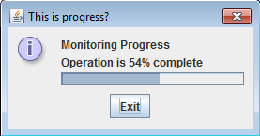

**Guidelines**